1. **Data Load:**

Unzip the files sent to you on your local PC (Dimensions contains dimensional data in excels and csv and Sales - fact data for several countries and years:

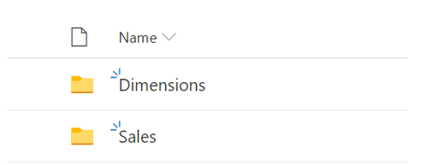

Use the base pbix sent to you to load the data as per the tasks below

Task 1.1:

Create two parameters for both **Dimensions** and **Sales** folder paths

Using the Parameters, load all dimension files and the 4 fact files. Set up the respective field data types. Make sure all dimensions have their PK unique.

Task 1.2:

Merge the different Sales into one Fact table.

1. Data Modeling:

Task 2.1:

Do the respective transformations to the Sales fact table in order to split the Country form the City in field “Location”. Make sure you set up the correct Data Type to allow Geo maps.

Do the necessary updates in the Date field to make sure you can setup the Date format.

Task 2.2:

Create unique key (GeoKey) in Sales and Geography table

Hint : The unique records are based on Country and City.

Task 2.3:

The Dimensional queries SalesRep and SubCategory need additional treatment. Some ID columns have the following format:

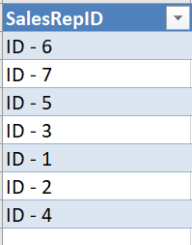

Create a small function that removes the “ID - ” part of these columns that you can invoke and reuse for these two queries to clean the IDs.

Task 2.4:

Create the Data Model connecting all tables and using the Calendar table already set up in the pbix.

1. DAX calculations

Task 3.1:

Calculate **Total Revenue** in Sales table, using the Product’s Retail Price, and multiplying it by the Units.

Task 3.2:

Calculate **Total Cost** in Sales table, using the Product’s Standard Cost, and multiplying it by the Units.

Task 3.3:

Calculate **Gross Profit**  in Sales : Total Revenue – Total Cost

Task 3.4:

Calculate a **Gross profit %** measure that could be sliced by Country, City and Product.

The % Gross Profit is a calculation **Gross Profit** /**Total Revenue**

**Hint :** the **Gross profit %** for Germany in 2017 is **68.95%**

Task 3.5:

Calculate a measure for **AVG sales per day** – this is the average sum of **Total Revenue** per day based on the Dates of actual Sales.

Task 3.6:

Create a **MS%** to show the Sales Market Share per each country (Country Total Revenue / Total Revenue of all sales)

Hint: Total Revenue of all sales is the Total Revenue of the whole Sales table. Make sure it can be filtered by each year, i.e the Total Revenue sales for each selected time period is a base of 100 %

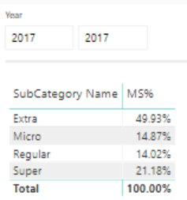 or 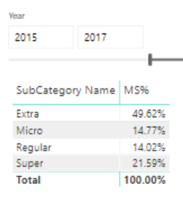

Task 3.7:

Calculate the following time measures:

* Total Revenue YTD
* Total Revenue YTD LY (Last Year)
* Total Revenue MAT (Moving Annual Total -last 12 months)
* Total Revenue MTD (Month to Date)

1. Use the measures and calculations to assemble a sales reports with different visuals to best show the Sales Insights in one page Dashboard. Feel free to use your imagination to best represent the data you have available.

If you plot Month on x-axis, make sure the months are sorted from Jan-Dec.